React Lab Report - BloggerApp

# Introduction

This lab explores different ways to do conditional rendering in React and rendering lists with keys.

# Objectives and What I Learned

- Render components using multiple conditional methods

- Use useState to toggle content views

- Use map() to loop through lists of data

- Provide unique keys when rendering lists

# Hands-on Practice Summary

Built 'bloggerapp' with BookDetails, BlogDetails, and CourseDetails components. Each is rendered conditionally based on selected view using if, ternary, and &&.

# Code Snippets

**App.js**

import React, { useState } from 'react';  
import BookDetails from './components/BookDetails';  
import BlogDetails from './components/BlogDetails';  
import CourseDetails from './components/CourseDetails';  
function App() {  
 const [view, setView] = useState("books");  
 return (  
 <div>  
 <button onClick={() => setView("books")}>Books</button>  
 <button onClick={() => setView("blogs")}>Blogs</button>  
 <button onClick={() => setView("courses")}>Courses</button>  
 {view === "books" && <BookDetails />}  
 {view === "blogs" ? <BlogDetails /> : null}  
 {view === "courses" && <CourseDetails />}  
 </div>  
 );  
}  
export default App;

# Screenshot

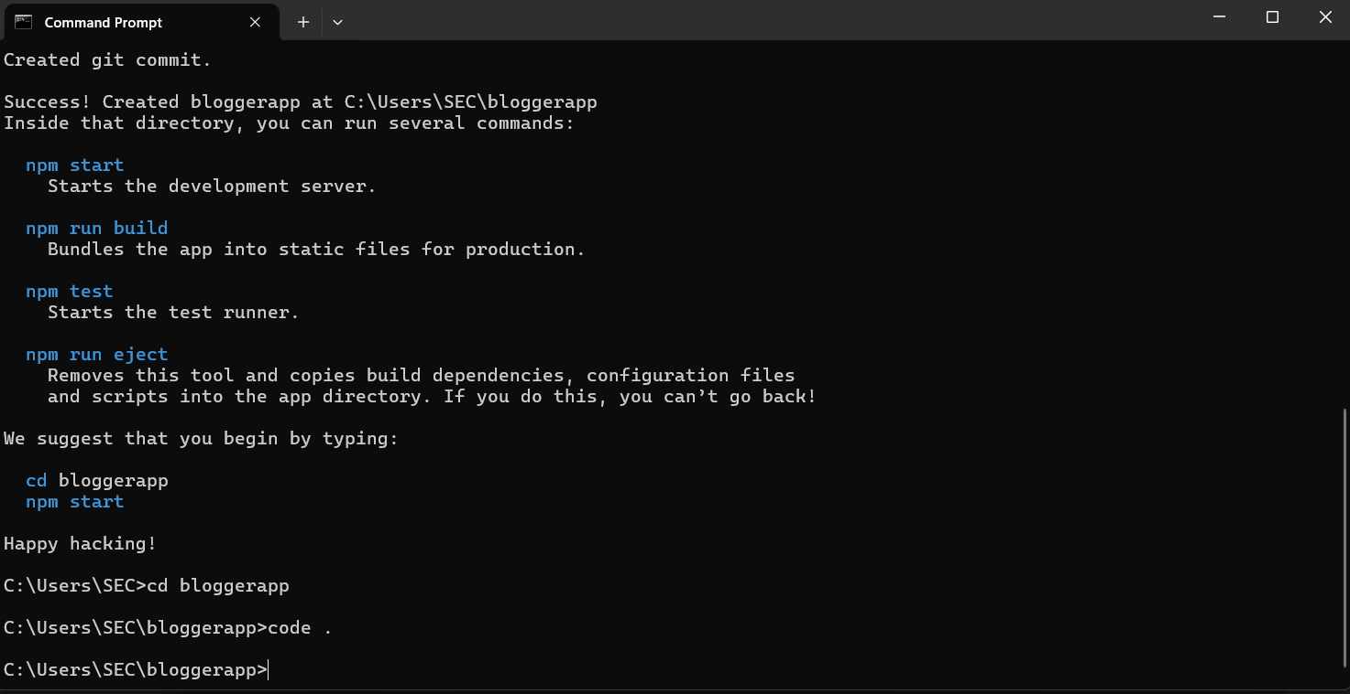

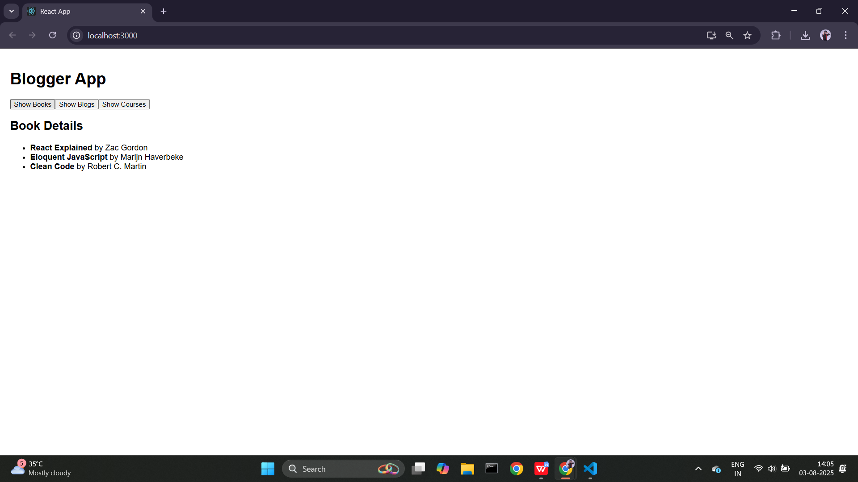

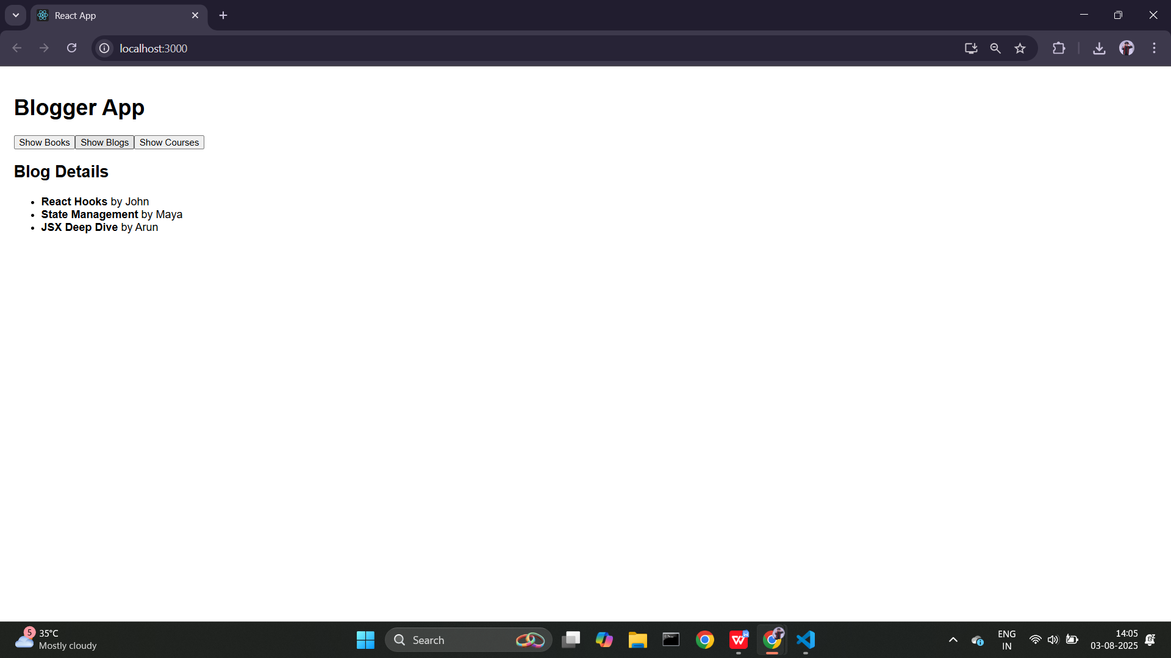

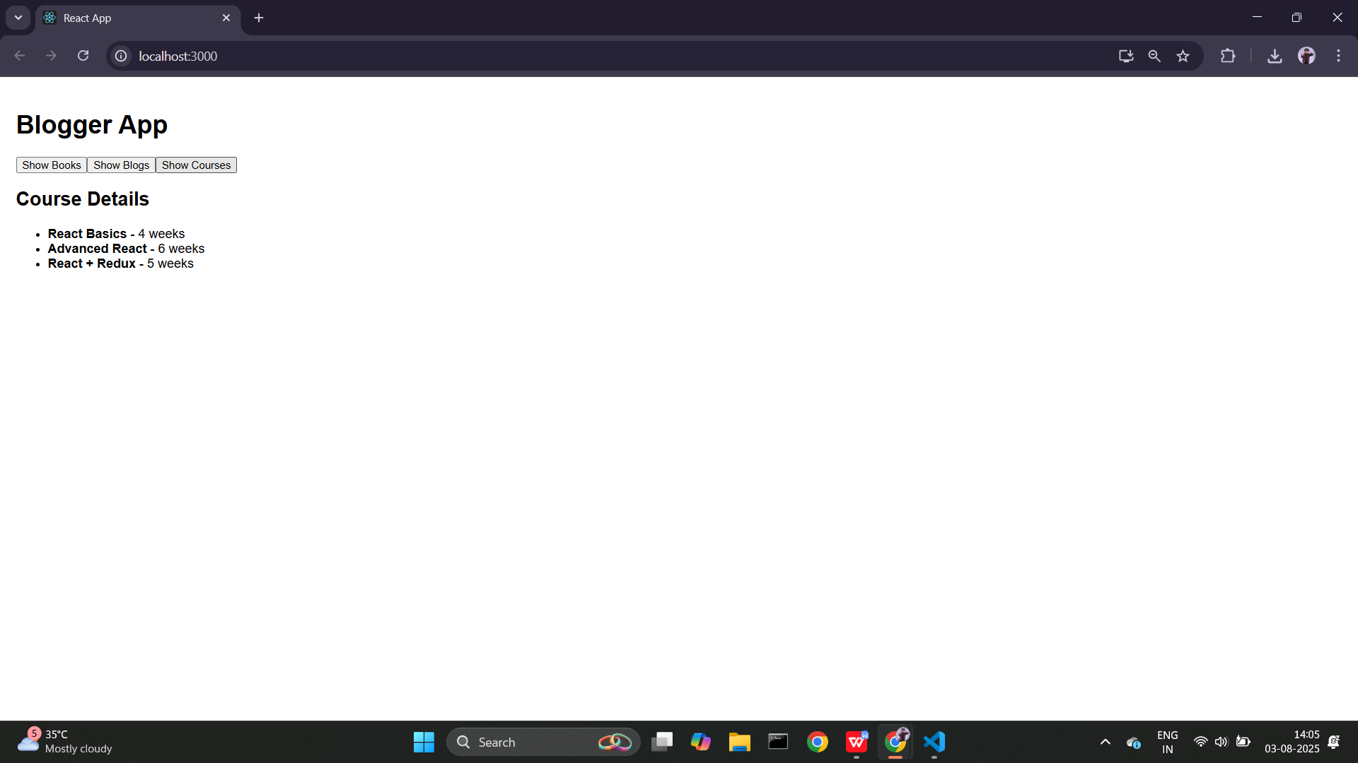

# Conclusion

This lab gave me strong hands-on practice in rendering lists with keys and switching between views using different rendering strategies.